South Central Behavioral Health region
FY21 Annual Service & Budget Plan

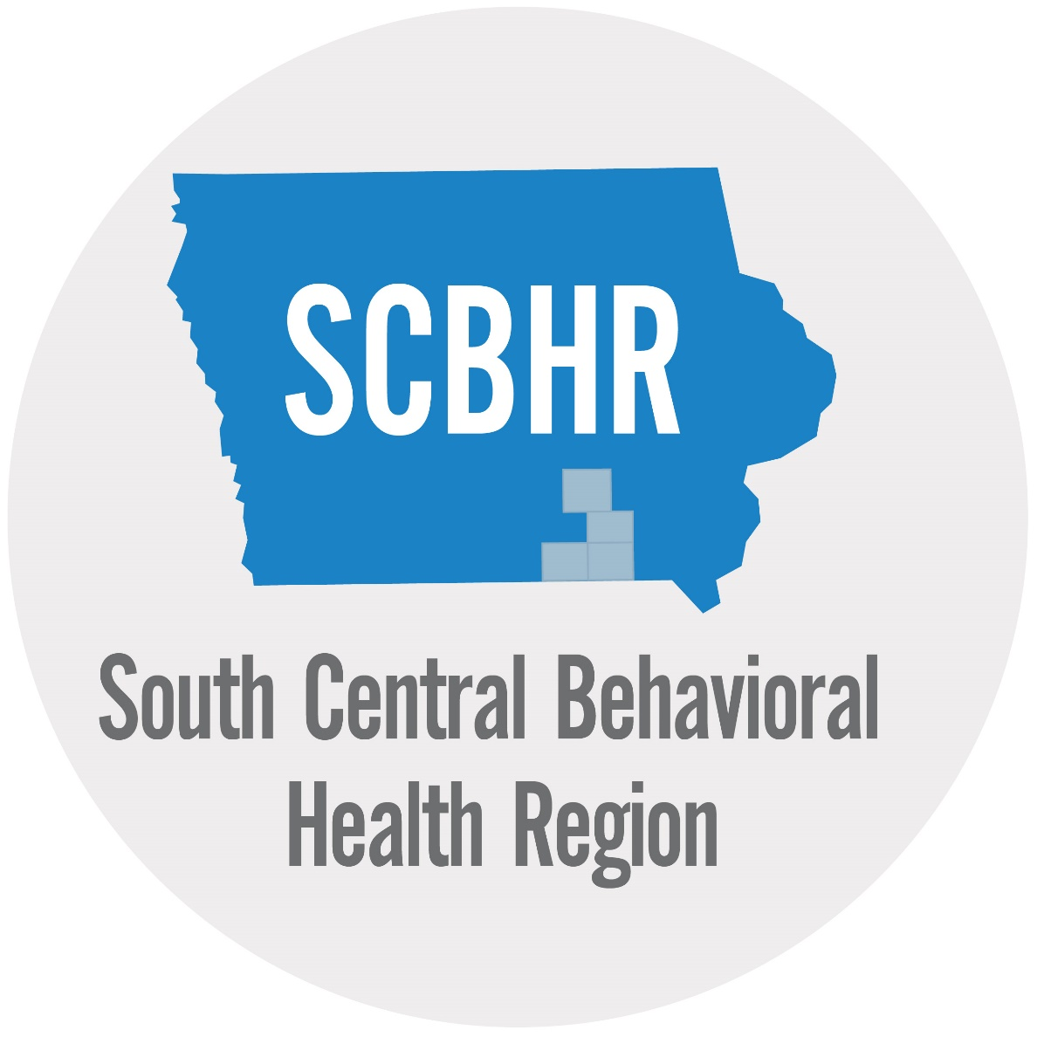

Submitted
4/28/2020

Geographic Area: Appanoose, Davis, Mahaska and Wapello
Approved by Advisory Board: 4/27/2020
Approved by Governing Board: 4/27/2020

Table of Contents

Introduction 2
A. Local Access Points 2
B. Service Coordination and Targeted Case Management 3
C. Crisis Planning 3
D. Intensive Mental Health Services 5
E. Scope of Services & Budget and Financing Provisions 5
Table A. Expenditures 6
Table B. Revenues 10
Table E. County Levies 11
G. Financial Forecasting Measures 11
H. Provider Reimbursement Provisions 11

Introduction
South Central Behavioral Health Region (SCBHR) was formed under Iowa Code Chapter 28E to create a Mental Health and Disability Service (MHDS) Region in compliance with Iowa Code 331.390. The annual service and budget plan is a component of the Management Plan which includes three parts: Annual Service and Budget Plan, Annual Report and Policies and Procedures Manual in compliance with Iowa Administrative Code 441.25.
The FY2021 Annual Service and Budget Plan covers the period of July 1, 2020 to June 30, 2021. The Annual Service and Budget Plan includes local access points, targeted case management providers, crisis services, intensive mental health services, a description of the scope of services to be provided including core services, budget and financial provisions, and provider reimbursement provisions.
Description of governing board and advisory boards provided in Appendix A attached.

A. Local Access Points
An access point is a part of the SCBHR service system trained to complete MHDS regional applications for persons with a disability.

SCBHR has designated the following access points for mental health and disability services.

Access Point | Location | Contact Information
Appanoose County Community Services Office | 209 E Jackson Street, Centerville Iowa, 52544 | 1-641-856-2085  Website:  www.scbhr.org
Davis County Community Services Office | 712 S. West, Bloomfield Iowa 52537 | 1-641-664-1993  Website:  www.scbhr.org
Mahaska County Community Services Office | 301 1st Avenue E., Oskaloosa, IA  52577 | 1-641-673-0410  Website: www.scbhr.org
Southern Iowa Mental Health Center | 1527 Albia Road, Ottumwa Iowa 52501 | Website:  https://www.simhcottumwa.org/  641-682-8772
Wapello County Community Services Office | 102 E. Main, Ottumwa Iowa 52501 | 1-641-683-4576  Website: www.scbhr.org

SCBHR has designated the following access points for children’s behavioral health services.

Access Point | Location | Contact Information
Appanoose County Community Services Office | 209 E Jackson Street, Centerville Iowa, 52544 | 1-641-856-2085  Website: www.scbhr.org
Davis County Community Services Office | 712 S. West, Bloomfield Iowa 52537 | 1-641-664-1993  Website: www.scbhr.org
Mahaska County Community Services Office | 301 1st Avenue E., Oskaloosa, IA  52577 | 1-641-673-0410  Website: www.scbhr.org
Wapello County Community Services Office | 102 E. Main, Ottumwa Iowa 52501 | 1-641-683-4576  Website: www.scbhr.org

B. Service Coordination and Targeted Case Management

The following agencies provide service coordination and/or targeted case management for SCBHR.

Service Coordination Provider | Adult/Child/Both | Location | Contact Information
Appanoose County Community Services Office | Adult/Children | 209 E Jackson Street, Centerville Iowa, 52544 | 1-641-856-2085  Website:www.scbhr.org
Davis County Community Services Office | Adult/Children | 712 S. West, Bloomfield Iowa 52537 | 1-641-664-1993  Website:www.scbhr.org
Mahaska County Community Services Office | Adult/Children | 301 1st Avenue E., Oskaloosa, IA  52577 | 1-641-673-0410  Website:www.scbhr.org
Wapello County Community Services Office | Adult/Children | 102 E. Main, Ottumwa Iowa 52501 | 1-641-683-4576  Website:www.scbhr.org
Southern Iowa Mental Health Center | Adult/Children | 1527 Albia Rd, Ottumwa, IA 52501  1229 C Avenue East, Oskaloosa, IA  52577 | 1-641-682-8772  Website:  https://www.simhcottumwa.org/  641-672-3159
Community Health Centers of Southern Iowa | Adult/Children | 302 NE 14th Street, Leon, IA 50144 | (641) 446-2383  Website: http://chcsi.org/
Amerigroup | Adults/Children | PO Box 71099, Clive, IA 50325 | 1-800-600-4441  TTY: 711  Website:  http://www.myamerigroup.com/IA
Iowa Total Care | Adults/Children | 1080 Jorden Creek Parkway,  West Des Moines, Iowa  50266 | 1-833-404-1061 (TTY: 711)  Website:  https://www.iowatotalcare.com/contact-us.html
DHS Case Management | Adults | 400 SW 8th St, Des Moines, IA 50319 | 515-242-6877

C. Crisis Planning

The following accredited crisis services are available to residents of the region for crisis prevention, response and resolution.

24 Hour Crisis Response
Provider | Location | Contact Information
Southern Iowa Mental Health Center | 1527 Albia Rd, Ottumwa, IA 52501  1229 C Avenue East, Oskaloosa, IA 52577 | 1-641-682-8772  Website: https://www.simhcottumwa.org/
Community Health Centers of Southern Iowa | 302 NE 14th Street, Leon, IA 50144 | (641) 446-2383  Website: http://chcsi.org/
Mercy Medical Centerville Iowa | 1 Old Hwy 5, Centerville, IA 52544 | (641) 437-4111  Website  https://www.mercyone.org/centerville/
Mahaska County Hospital | 1229 C Avenue East  Oskaloosa, Iowa 52577 | 641.672.3100  Website:  http://www.mahaskahealth.org/

24 Hour Crisis Hotline
Provider | Location | Contact Information
Southern Iowa Mental Health Center | 1527 Albia Rd, Ottumwa, IA 52501 | 1-641-682-8772  Website:  https://www.simhcottumwa.org/
Foundation 2 | 1714 Johnson Ave NW  Cedar Rapids, IA 52405 | 1-800-332-4224, 319-362-2174  1-844-430-8520  Website:  https://www.foundation2.org/

Crisis Evaluation
Provider | Adult/Child/Both | Location | Contact Information
Southern Iowa Mental Health | Adult/Children | 1527 Albia Rd, Ottumwa, IA 52501  1229 C Avenue East, Oskaloosa, IA 52577 | 1-641-682-8772  Website:  https://www.simhcottumwa.org/
Community Health Centers of Southern Iowa | Adult/Children | 302 NE 14th Street, Leon, IA 50144 | (641) 446-2383  Website:  http://chcsi.org/

Mobile Response
Provider | Location | Contact Information
Southern Iowa Mental Health | 1527 Albia Rd, Ottumwa, IA 52501 | 1-844-430-8520  Website:  https://www.simhcottumwa.org/

Crisis Stabilization Community-based Services
Provider | Adult/Child | Location | Contact Information
N/A

Crisis Stabilization Residential Services
Provider | Adult/Child | Location | Contact Information
Southern Iowa Mental Health | Adult | 1527 Albia Rd, Ottumwa, IA 52501 | 641-682-8772  Website:  https://www.simhcottumwa.org/

23-Hour Observation
Provider | Location | Contact Information
Southern Iowa Mental Health | 1527 Albia Rd, Ottumwa, IA 52501 | 641-682-8772  Website:  https://www.simhcottumwa.org/

SCBHR honors all Regional contracts for Crisis Services to provide access to our SCBHR clients when in need of the Crisis Services wherever the location.

D. Intensive Mental Health Services

The region has designated the following provider(s) as an Access Center that meet the requirements according to IAC 441—25.6(1) in a coordinated manner in one or more locations:

Provider | Location | Contact Information
N/A

The region has designated the following Assertive Community Treatment (ACT) teams which have been designated and meet the requirements in IAC 441—25.6(2).

Provider | Location | Contact Information
N/A

The region has designated the following Subacute service providers which meet the criteria and are licensed by the Department of Inspections and Appeals.

Provider | Location | Contact Information
N/A

The region has designated the following Intensive Residential Service providers which have been designated and meet the requirements in IAC 441—25.6(8):

Provider | Location | Contact Information
N/A

E. Scope of Services & Budget and Financing Provisions
The table below identifies the scope of services offered by SCBHR. All core services are available. If there is not funding identified in a core service column, it is because it has not been needed historically. If an individual needs funding for a core service and meets eligibility requirements found in section F of the SCBHR policy and procedure manual, funding will be made available. Core services for children’s behavioral health are identified by (**) after the service name. Eligibility guidelines for children’s behavioral health services are located in section F, page 14 of the SCBHR policy and procedure manual. The Policy and procedure manual can be found online as of 07/01/2020 at: www.scbhr.org
The region will utilize braided funding that includes county, regional, state and other funding sources as necessary and available to meet the service needs within the region.

Table A. Expenditures
FY 2021 Budget | SCBHR | MI (40) | ID(42) | DD(43) | BI (47) | Admin (44) | Total
Core Domains
COA | Treatment
42305 | Mental health outpatient therapy ** | $ 10,000 |  |  |  |  | $ 10,000
42306 | Medication prescribing & management ** |  |  |  |  |  | $ -
43301 | Assessment, evaluation, and early identification ** | $ 10,000 |  |  |  |  | $ 10,000
71319 | Mental health inpatient therapy-MHI | $ 50,000 |  |  |  |  | $ 50,000
73319 | Mental health inpatient therapy ** | $ 100,000 |  |  |  |  | $ 100,000
 | Crisis Services
32322 | Personal emergency response system |  |  |  |  |  | $ -
44301 | Crisis evaluation | $ 120,000 |  |  |  |  | $ 120,000
44302 | 23 hour crisis observation & holding | $ 250,000 |  |  |  |  | $ 250,000
44305 | 24 hour access to crisis response |  |  |  |  |  | $ -
44307 | Mobile response ** | $ 200,000 |  |  |  |  | $ 200,000
44312 | Crisis Stabilization community-based services ** |  |  |  |  |  | $ -
44313 | Crisis Stabilization residential services ** | $ 250,000 |  |  |  |  | $ 250,000
44396 | Access Centers: start-up / sustainability |  |  |  |  |  | $ -
 | Support for Community Living
32320 | Home health aide |  |  |  |  |  | $ -
32325 | Respite |  |  |  |  |  | $ -
32328 | Home & vehicle modifications |  |  |  |  |  | $ -
32329 | Supported community living | $ 300,000 |  |  |  |  | $ 300,000
42329 | Intensive residential services |  |  |  |  |  | $ -
 | Support for Employment
50362 | Prevocational services |  |  |  |  |  | $ -
50364 | Job development | $ 5,000 |  |  |  |  | $ 5,000
50367 | Day habilitation |  |  |  |  |  | $ -
50368 | Supported employment | $ 2,500 |  |  |  |  | $ 2,500
50369 | Group Supported employment-enclave |  |  |  |  |  | $ -
 | Recovery Services
45323 | Family support |  |  |  |  |  | $ -
45366 | Peer support |  |  |  |  |  | $ -
 | Service Coordination
21375 | Case management |  |  |  |  |  | $ -
24376 | Health homes |  |  |  |  |  | $ -
 | Sub-Acute Services
63309 | Subacute services-1-5 beds | $ 50,000 |  |  |  |  | $ 50,000
64309 | Subacute services-6 and over beds |  |  |  |  |  | $ -
 | Core Evidenced Based Treatment
04422 | Education & Training Services - provider competency |  |  |  |  |  | $ -
32396 | Supported housing | $ 175,000 |  |  |  |  | $ 175,000
42398 | Assertive community treatment (ACT) | $ 100,000 |  |  |  |  | $ 100,000
45373 | Family psychoeducation | $ 10,000 |  |  |  |  | $ 10,000
 | Core Domains Total | $ 1,632,500 | $ - | $ - | $ - |  | $ 1,632,500
Mandated Services
46319 | Oakdale | $ 2,500 |  |  |  |  | $ 2,500
72319 | State resource centers |  |  |  |  |  | $ -
74XXX | Commitment related (except 301) | $ 107,000 |  |  |  |  | $ 107,000
75XXX | Mental health advocate | $ 80,000 |  |  |  |  | $ 80,000
 | Mandated Services Total | $ 189,500 | $ - | $ - | $ - |  | $ 189,500
Additional Core Domains
 | Justice system-involved services
25xxx | Coordination services |  |  |  |  |  | $ -
44346 | 24 hour crisis line* | $ 40,000 |  |  |  |  | $ 40,000
44366 | Warm line* | $ 15,000 |  |  |  |  | $ 15,000
46305 | Mental health services in jails | $ 250,000 |  |  |  |  | $ 250,000
46399 | Justice system-involved services-other |  |  |  |  |  | $ -
46422 | Crisis prevention training | $ 20,000 |  |  |  |  | $ 20,000
46425 | Mental health court related costs |  |  |  |  |  | $ -
74301 | Civil commitment prescreening evaluation |  |  |  |  |  | $ -
 | Additional Core Evidenced based treatment
42366 | Peer self-help drop-in centers | $ 560,000 |  |  |  |  | $ 560,000
42397 | Psychiatric rehabilitation (IPR) |  |  |  |  |  | $ -
 | Additional Core Domains Total | $ 885,000 | $ - | $ - | $ - |  | $ 885,000
Other Informational Services
03371 | Information & referral |  |  |  |  |  | $ -
04372 | Planning, consultation &/or early intervention (client related) ** | $ 229,100 |  |  |  |  | $ 229,100
04377 | Provider Incentive Payment |  |  |  |  |  | $ -
04399 | Consultation Other |  |  |  |  |  | $ -
04429 | Planning and Management Consultants (non-client related) | $ 48,000 |  |  |  |  | $ 48,000
05373 | Public education, prevention and education ** | $ 72,000 |  |  |  |  | $ 72,000
 | Other Informational Services Total | $ 349,100 | $ - | $ - | $ - |  | $ 349,100
Community Living Supports
06399 | Academic services |  |  |  |  |  | $ -
22XXX | Services management | $ 387,581 |  |  |  |  | $ 387,581
23376 | Crisis care coordination |  |  |  |  |  | $ -
23399 | Crisis care coordination other |  |  |  |  |  | $ -
24399 | Health home other |  |  |  |  |  | $ -
31XXX | Transportation | $ 15,000 |  |  |  |  | $ 15,000
32321 | Chore services |  |  |  |  |  | $ -
32326 | Guardian/conservator |  |  |  |  |  | $ -
32327 | Representative payee |  |  |  |  |  | $ -
32335 | CDAC |  |  |  |  |  | $ -
32399 | Other support |  |  |  |  |  | $ -
33330 | Mobile meals |  |  |  |  |  | $ -
33340 | Rent payments (time limited) |  |  |  |  |  | $ -
33345 | Ongoing rent subsidy | $ 35,000 |  |  |  |  | $ 35,000
33399 | Other basic needs | $ 8,000 |  |  |  |  | $ 8,000
41305 | Physiological outpatient treatment | $ 250 |  |  |  |  | $ 250
41306 | Prescription meds | $ 30,000 |  |  |  |  | $ 30,000
41307 | In-home nursing |  |  |  |  |  | $ -
41308 | Health supplies |  |  |  |  |  | $ -
41399 | Other physiological treatment |  |  |  |  |  | $ -
42309 | Partial hospitalization |  |  |  |  |  | $ -
42310 | Transitional living program |  |  |  |  |  | $ -
42363 | Day treatment |  |  |  |  |  | $ -
42396 | Community support programs |  |  |  |  |  | $ -
42399 | Other psychotherapeutic treatment |  |  |  |  |  | $ -
43399 | Other non-crisis evaluation |  |  |  |  |  | $ -
44304 | Emergency care |  |  |  |  |  | $ -
44399 | Other crisis services |  |  |  |  |  | $ -
45399 | Other family & peer support |  |  |  |  |  | $ -
46306 | Psychiatric medications in jail | $ 70,000 |  |  |  |  | $ 70,000
50361 | Vocational skills training |  |  |  |  |  | $ -
50365 | Supported education |  |  |  |  |  | $ -
50399 | Other vocational & day services |  |  |  |  |  | $ -
63XXX | RCF 1-5 beds (63314, 63315 & 63316) |  |  |  |  |  | $ -
63XXX | ICF 1-5 beds (63317 & 63318) |  |  |  |  |  | $ -
63329 | SCL 1-5 beds |  |  |  |  |  | $ -
63399 | Other 1-5 beds |  |  |  |  |  | $ -
 | Community Living Supports | $ 545,831 | $ - | $ - | $ - |  | $ 545,831
Other Congregate Services
50360 | Work services (work activity/sheltered work) |  |  |  |  |  | $ -
64XXX | RCF 6 and over beds (64314, 64315 & 64316) | $ 150,000 |  |  |  |  | $ 150,000
64XXX | ICF 6 and over beds (64317 & 64318) |  |  |  |  |  | $ -
64329 | SCL 6 and over beds |  |  |  |  |  | $ -
64399 | Other 6 and over beds |  |  |  |  |  | $ -
 | Other Congregate Services Total | $ 150,000 | $ - | $ - | $ - |  | $ 150,000
Administration
11XXX | Direct Administration |  |  |  |  | 601,628 | $ 601,628
12XXX | Purchased Administration |  |  |  |  |  | $ -
 | Administration Total |  |  |  |  | $ 601,628 | $ 601,628
 | Regional Totals | $ 3,751,931 | $ - | $ - | $ - | $ 601,628 | $ 4,353,559
(45XX-XXX)County Provided Case Management |  |  |  |  |  |  | $ -
(46XX-XXX)County Provided Services |  |  |  |  |  |  | $ -
 | Regional Grand Total |  |  |  |  |  | $ 4,353,559
Transfer Numbers (Expenditures should only be counted when final expenditure is made for services/administration. Transfers are eliminated from budget to show true regional finances)
13951 | Distribution to MHDS regional fiscal agent from member county |  |  |  |  |  | $ 2,661,885
14951 | MHDS fiscal agent reimbursement to MHDS regional member county |  |  |  |  |  | $ -
*24 hour crisis line and warm line are transitioning from additional core to state wide core services with state funding.
**Core services for children with a serious emotional disturbance (SED)

Table B. Revenues
 | FY 2021 Budget | South Central Behavioral Health Region
 | Revenues
 |  | Projected Fund Balance as of 6/30/20 |  |  |  | $ 3,152,913
 |  | Local/Regional Funds |  |  |  | $ 3,718,998
 | 10XX | Property Tax Levied |  |  | -
 | 12XX | Other County Taxes |  |  | -
 | 16XX | Utility Tax Replacement Excise Taxes |  |  | -
 | 25XX | Other Governmental Revenues |  |  | -
 | 4XXX-5XXX | Charges for Services |  |  | -
 | 5310 | Client Fees |  |  | -
 | 60XX | Interest |  |  | -
 | 6XXX | Use of Money & Property |  |  | -
 | 8XXX | Miscellaneous |  |  | -
 | 9040 | Other Budgetary Funds (Polk Only) |  |  | -
 |  |  |  |  | -
 |  | State Funds |  |  |  | $ -
 | 21XX | State Tax Credits |  |  | -
 | 22XX | Other State Replacement Credits |  |  | -
 | 2250 | MHDS Equalization |  |  | -
 | 24XX | State/Federal pass thru Revenue |  |  | -
 | 2644 | MHDS Allowed Growth / State Gen. Funds |  |  | -
 | 29XX | Payment in Lieu of taxes |  |  | -
 |  |  |  |  | -
 |  | Federal Funds |  |  |  | $ -
 | 2344 | Social services block grant |  |  | -
 | 2345 | Medicaid |  |  | -
 |  | Other |  |  | -
 |  | Total Revenues |  |  |  | $ 3,718,998
 |  | Total Funds Available for FY21 |  |  | $ 6,871,911
 |  | FY21 Projected Regional Expenditures |  |  | $ 4,353,559
 |  | Projected Accrual Fund Balance as of 6/30/21 |  |  | $ 2,518,352

Table E. County Levies
County | 2018 Est. Pop. | Regional Per Capita | FY21 Max Levy | FY21 Actual Levy | Actual Levy Per Capita
Appanoose | 12,437 | 47.28 | 588,021 | $ 588,021 | 47.28
Davis | 9,017 | 47.28 | 426,324 | $ 426,324 | 47.28
Mahaska | 22,000 | 47.28 | 1,040,160 | $ 1,040,160 | 47.28
Wapello | 35,205 | 47.28 | 1,664,492 | $ 1,664,492 | 47.28
SCBHR | 78,659 |  | 3,718,998 | 3,718,997 | 47.28

G. Financial Forecasting Measures

The following is a description of the financial forecasting measures used by SCBHR in the identification of service need and funding necessary for services.
SCHBR, will collaborate with stakeholders and advisory committee members throughout FY21 to determine service needs of the community and training needs of the providers. Due to the reduction of fund balance in FY19 and FY20 SCBHR has not budgeted in FY21 to build new services to include Community Based Stabilization for Children/Adults, Crisis Residential Beds for Children and Intensive Residential Homes for Adults. At current all counties are levying the max at $47.28 counties are setting at 24-25% fund balance. Due to this the region will be projected to use approximately a million dollars of regional fund balance one-time money to cover FY21 expenditures. SCBHR is analyzing the DHS identified braid funding sources as the region has subsidized development, access to service, and sustainability. Financial sustainability is being called into question as related to fee for service structures and the cost settled rates based on the actual cost to operate services for which the region is absorbing all cost. The region’s goal to sustain the service system at current with the hopes that Managed Care Organizations will start funding Medicaid services to relieve the region of 100% cost of Crisis Services. If this were to happen the Advisory Committee and stakeholders would then begin the prioritizing of building additional core services due by July 2021. At current the region has met the core service timeline both for adult core services and children core services.

H. Provider Reimbursement Provisions

The following is a description of the types of funding used by SCBHR
- Fee for service:
SCBHR will contract with MHDS providers whose base of operation is within the region. SCBHR may also honor contracts that other regions have with their local providers or may choose to contract with providers outside of the region. A contract may not be required with providers that provide one-time or as needed services. A fee for service approach will be utilized in most provider contracts outlining the services to be provided and the rate of reimbursement. All payments will be based on a pre-authorized request for service authorization with the exception of court ordered payments, such as civil commitment costs and crisis services.

- Block grant payments:
SCBHR currently funds Southern Iowa Mental Health Center, First Resources and Optimae under the payment provision of a block grant. Services rendered include Drop-in Centers in Appanoose, Davis, Mahaska and Wapello Counties. Southern Iowa Mental Health Center receives block grant dollars to support Planning and or Consultation Services (client), Planning and Management Consultants (non-client) and Public Education Service block grant dollars. SCBHR uses block grant dollars to off-set the cost of the Assertive Community Treatment Team through Southern Iowa Mental Health Center along with the short-fall for Crisis Services offered at Southern Iowa Mental Health Center.

- Use of nontraditional providers:
When a non-traditional provider arrangement is more appropriate than a fee for service approach with a contracted provider, the Coordinators of Disability Services will work with the region’s CEO to request such arrangements. A non-traditional provider may be an individual, organization and/or business who delivers services in the consumer’s home and/or other community setting. Non-traditional providers typically are individuals, organizations, or businesses which do not provide MHDS services as a part of their normal business. These services are not to provide treatment but are supportive and may be rehabilitative in focus, and are initiated when there is a reasonable likelihood that such services will benefit the consumer’s functioning, assist them in maintaining community tenure, and act as an alternative way to achieve the consumer’s stated goals or outcomes. A request for funding can be made by any consumer, or the consumer’s authorized representative, to utilize non-traditional providers for services as approved in the Regional Management Plan. Non-traditional providers may be subject to certain licensing, certification, accreditation or other state approval standards.

- Incorporation of all funding sources for individuals including Medicaid:
The Region is responsible for ensuring that MHDS services are available to all residents of the region regardless of funding source. SCBHR will ensure that individuals apply for all funding sources prior to accessing regional funding, including private insurance, Medicaid, Medicare and other funding mechanisms which ensure that individuals and their families are able to optimally live, work, and recreate in integrated communities of their choice.

